

Promoting Positive Behaviour

At Little Adventurers Nursery we believe that children flourish best when they feel safe and secure and have their needs met by supportive practitioners who act as good role models, show them respect and value their individual personalities. Children are supported through co-regulation, where adults and children work together towards a common purpose, including finding ways to resolve upsets from stress in any domain and return to balance leading onto a path to self-regulation. The nursery actively promotes British values and encourages and praises positive, caring and polite behaviour at all times and provides an environment where children learn to respect themselves, other people and their surroundings.
We implement the early years curriculum supporting children to develop their personal, social and emotional development. This involves helping children to understand their own feelings and others and beginning to regulate their behaviour. We support children to do this through working together with parents, having consistent approaches, structure, routine and age/stage appropriate boundaries appropriate to the emotional development of the child. We help build confidence and self-esteem by valuing all children and giving lots of praise and encouragement.
To support positive behaviour in our setting, we aim to:
• Recognise the individuality of all our children
• Provide a warm, responsive relationship where children feel respected, comforted and supported in times of stress, and confident that they are cared for at all times
• Understand that certain behaviours are a normal part of some young children’s development, e.g. biting but that staff are ready to prevent accidents and incidents.
• Encourage self-regulation, consideration for each other, our surroundings and property
• Encourage children to participate in a wide range of group activities to enable them to develop their social skills
• Ensure that all staff act as positive role models for children and ensuring that when in charge staff have a clear view of the children in the room.
• Encourage parents, carers and other visitors to be positive role models
• Work in partnership with parents by communicating openly
• Praise children and acknowledge their positive actions and attitudes, therefore ensuring that children see that we value and respect them
• Ensure all children are safe by promptly intervening to behaviours that may pose a risk to the child e.g. a child climbing on furniture. Staff working with children must accept their responsibility for acting quickly to ensure the safety and promotion of positive behaviour of children in our care. Staff taking lead should take responsibility for the safety of the room/ environment and act immediately if another staff member is not following policy. They should then report to management who are available at all times on or off site and follow our whistleblowing policy to keep children safe in our care.
• Promote non-violence and encourage children to deal with conflict peacefully and safety
• Provide a key person system enabling staff to build a strong and positive relationship with children and their families
• Provide activities and stories to help children learn about accepted behaviours, including opportunities for children to contribute to decisions about accepted behaviour where appropriate
• Supporting and developing children’s understanding of different feelings and emotions, self- regulation and empathy as appropriate to stage of development. This includes using strategies and naming and talking about feelings and ways to manage them
• Have a named person who has overall responsibility for promoting positive behaviour and behaviour support.
Consistency is the key to achieving successful behavioural outcomes in children. Adults supporting children must have a clear understanding of the approaches the nursery takes to supporting children’s behaviour.
This behaviour policy forms the backbone of the behavioural approaches implemented at the nursery and should be read and understood by staff and parents.
Rationale
At Little Adventurers Nursery, the ethos is one of nurture, support, and compassion. We believe that children flourish when they feel safe, in an environment where there are boundaries, expectations and support. We aim to ensure that all children and their families are supported to develop nurturing relationships that promote their long-term health and wellbeing.
Young children have specific emotional, social, and mental health needs, which need to be nurtured and met by adults who are knowledgeable of these needs. A report commissioned by Anna Freud has highlighted the change in some children’s emotional and social needs as a direct result of the Covid-19 pandemic. This policy and the behavioural support strategies implemented across Little Adventurers nursery, reflect the findings of the Anna Freud report.
Attachment ideas
At Little Adventurers, we apply attachment ideas to support young children who display challenging behaviour in the setting. What do we mean by attachment ideas?
• Our ‘key persons’ are key attachment figures for young children.
• Young children instinctively seek out caregivers for comfort and protection. Caregivers are primed to understand and respond to these needs, both physical and emotional.
• Children who trust that caregivers are willing and able to recognise and help with distress, feel safe, secure and able to explore and learn.
• The priority is not to stop or prevent challenging behaviour, but to create an environment in which children feel we are interested in trying to help and understand with difficult feelings. In doing so, children are better equipped to play, learn and explore their world.
Positive Behaviour Support
At Little Adventurers we believe that positive behaviour management is the most effective tool for encouraging and promoting acceptable behaviour in young children.

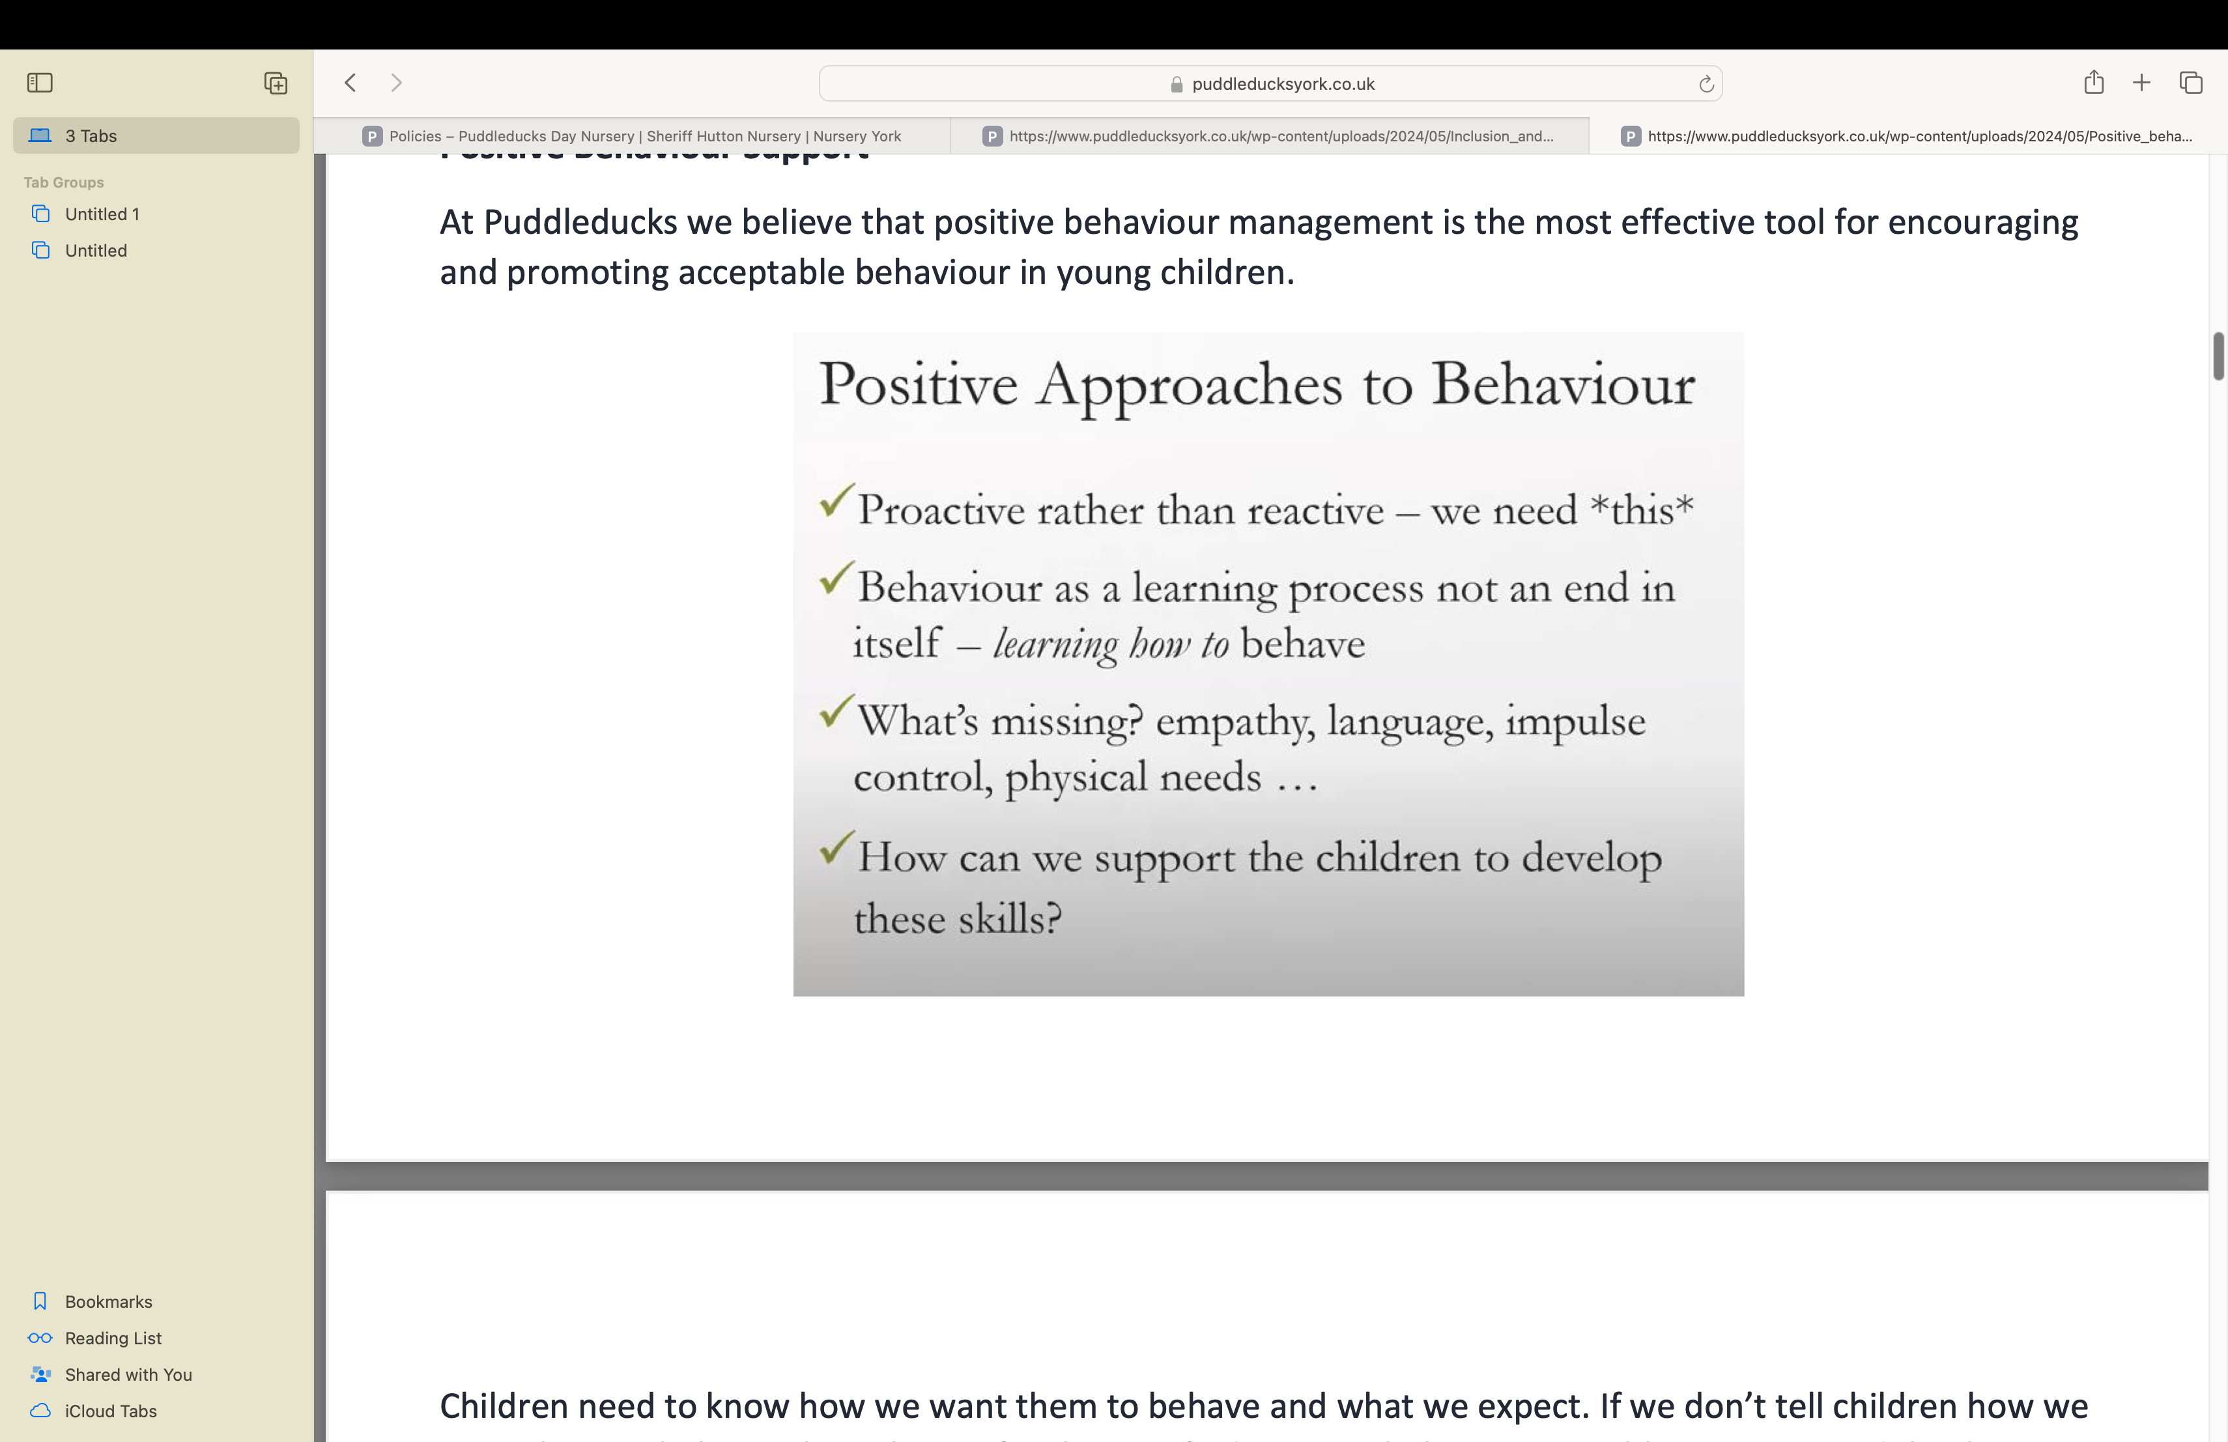

Children need to know how we want them to behave and what we expect. If we don’t tell children how we want them to behave, the only way for them to find out is to behave in a problematic way. Adults then react to problematic behaviour and so begins a negative spiral. Getting in front of this and making behavioural expectations clear is essential.
We promote and encourage lots of conversations about behaviour because children are not the finished product. Children are at the very begin of a process of learning how to behave; how to regulate feelings and learning what is acceptable. They need to be taught this, just like they need to be taught to count. Just like we encourage an environment rich in numbers to support children to learn numbers, we need an environment rich in behavioural language and behavioural examples in order for children to learn these skills.
We wouldn’t get cross with a child who is struggling to learn to read or ride a bike. Learning to behave appropriately is no exception. Behaviour is something to be taught and learnt, just like reading, writing or number.
In supporting children to learn to behave, it is important to consider what skills they are missing. Often the lacking skill will relate to empathy.
What is challenging behaviour?
Challenging behaviour can mean lots of different things.
It can be behaviour which is :-
• Aggressive (e.g. snatching, shouting, pushing etc.)
• Dangerous (e.g. hitting, biting, scratching, throwing, climbing.)
• Destructive (e.g. breaking or damaging books, toys, furniture.)
• Distressed or distressing (e.g. crying, screaming, shouting, rocking.)
Behaviour that makes us feel anxious, upset, angry or powerless.

Challenging Behaviour
What the above have in common, is the feelings that they all elicit in the adults looking after children. Feelings of upset, anxiety, anger, sadness for the child for example. These feelings are natural, and important in making us notice, and in making us want to do something to support the child.

Why do toddlers and young children show challenging behaviour?
• Young children communicate feelings through behaviour.
• Children’s capacity to regulate emotions is still developing.
• Aggression is normal and essential.
• BUT strong feelings are frightening, and young children need:
- Reassurance that these feelings are ok
- Help to use aggression constructively rather than destructively

In the moment :-

1. Regulate yourself
Try not to be impulsive. Try not to act immediately. Try to
be respectful. Ask, do I need to do anything this instant
or can I take 30 seconds to take some deep breathes?
For children this models our capacity to sit with feelings,
stay calm and think before acting. It also gives
time for you to think about what the child is

communicating with this behaviour.
2. Use the language of safety
Talk to children about their behaviour in the language
of safety. Is this behaviour ‘safe or not safe’ rather than
‘kind or unkind’. This is very effective. Young children are
prone to feeling shame and we want to avoid this.
Emphasise you are setting a boundary to keep
them safe.
3. Acknowledge big feelings

Acknowledge & show that you understand the child is
feeling big emotions and that you know those feelings
are the driver for the behaviour. Let them know you
might need to stop their actions but that the feeling
itself is ok.
Avoid saying BUT. ‘’Its ok to be cross BUT
we cannot hit our friend’’. Acknowledge
the feeling instead. ‘’I know it made you
really cross when your friend took
the car from you. ‘’

It is ordinary and normal for young children to show challenging behaviour because they have not learnt to manage feelings yet and can become overwhelmed by some feelings. The capacity to manage feelings is still developing and children cannot reflect on feelings or verbalise them. This needs to be learnt. The rational part of the brain that allows us to process overwhelming feelings and stop us from acting on them immediately is still developing in young children.
Young children have very limited ability to take other people’s perspectives.
Aggression is normal and allows children to assert themselves; to communicate what they like and what they don’t like and set boundaries for themselves. Strong feelings are really frightening for young children, and to help them manage those feelings, children need reassurance that those feelings are ok, and that it is ok for them to have those feelings.
Children need to know that if they express strong feelings, adults will not think any less of them; they will not dislike them, and they will not stop looking after them.
Children need to be shown how to use aggression constructively rather than destructively, or harmfully.
Every situation that we find ourselves in with young children is different so there can be no ‘one size fits all’ approach. It is impossible to document a guide that states when ‘X’ happens, do ‘Y’, but we can and must apply the same principles to every situation involving challenging behaviour.
In the moment :-
1. Regulate yourself
Try not to be impulsive. Try not to act immediately. Try to
be respectful. Ask, do I need to do anything this instant
or can I take 30 seconds to take some deep breathes?
For children this models our capacity to sit with feelings,
stay calm and think before acting. It also gives time for
you to think about what the child is communicating
with this behaviour.
2. Use the language of safety
Talk to children about their behaviour in the language
of safety. Is this behaviour ‘safe or not safe’ rather than
‘kind or unkind’. This is very effective. Young children are
prone to feeling shame and we want to avoid this.
Emphasise you are setting a boundary to keep them
safe.
3. Acknowledge big feelings
Acknowledge & show that you understand the child is
feeling big emotions and that you know those feelings
are the driver for the behaviour. Let them know you
might need to stop their actions but that the feeling
itself is ok.
Avoid saying BUT. ‘’Its ok to be cross BUT we cannot hit
our friend’’. Acknowledge the feeling instead. ‘’I know it
made you really cross when your friend took the car
from you. ‘’
Little Adventurers Key Principles of Behaviour Support
These principles will not magically stop a behaviour but will contribute to the child’s sense of their own strong feelings being manageable and eventually being able to find way to express big feelings.
It can be difficult to practice and achieve all 3 of these principles in the moment, but we should aim to implement these 3 core principles.

After the event:-
4. Go beyond the behaviour
Aggression is often the flipside of fear and children often lash
out because they’re frightened or threatened. That threat
might not be an obvious external one. It might be something
inside the child; anxiety, fear, shame. Talk to colleagues and
parents to try and build a picture to understand what might
be going on.
5. Reflect on upset and recovery
Debriefing without dwelling too much. Model that it is safe to
talk about those overwhelming feelings, how the child
behaved and how they calmed down. Children find it very
reassuring to talk through the whole process of being
overwhelmed and then managing to calm down.
6. Create opportunities to safely express
difficult feelings
Provide opportunities for children to express feelings through
play & story telling. Observing children hurting the teddies,
pushing the dolls out of the pram, narrate this for children
and use this as a clue to help understand what is going on
internally.

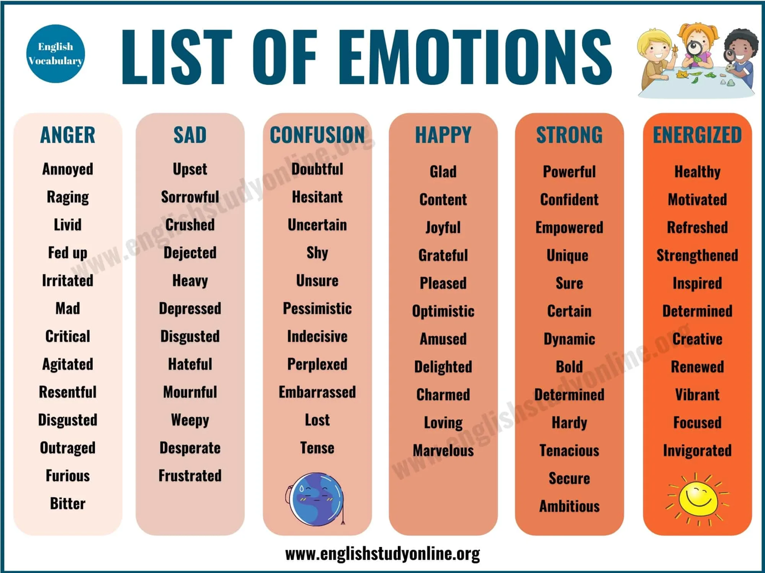

Communication, Language and Behaviour
Children with language delay will often display challenging behaviour as they struggle to express themselves emotionally. They often behaviour impulsively because they cannot express what they are feeling. Where children have language delay, challenging behaviour is a symptom, and it is important that the language delay is recognised and support for this sought. The setting SENCO should be consulted, and practitioners should request her support in targeted interventions and/or referrals to speech and language therapists.
All behaviours are a form of communication. Children communicate positive things to us in non-verbal ways, through their behaviour all the time. They might communicate that they are happy or excited by
After the event:-
4. Go beyond the behaviour
Aggression is often the flipside of fear and children often lash
out because they’re frightened or threatened. That threat
might not be an obvious external one. It might be something
inside the child; anxiety, fear, shame. Talk to colleagues and
parents to try and build a picture to understand what might
be going on.
5. Reflect on upset and recovery
Debriefing without dwelling too much. Model that it is safe to
talk about those overwhelming feelings, how the child
behaved and how they calmed down. Children find it very
reassuring to talk through the whole process of being
overwhelmed and then managing to calm down.
6. Create opportunities to safely express difficult feelings
Provide opportunities for children to express feelings through
play & story telling. Observing children hurting the teddies,
pushing the dolls out of the pram, narrate this for children
and use this as a clue to help understand what is going on
internally.
They might communicate that they love you through cuddling. The more we can learn to read those behaviours, the more we can work out what these behaviours are telling us about the child. What does the child need? What do they still need to learn?
If as practitioners we think of behaviour as communication, it should help prevent us having an instinctive reaction to behaviour. ALL behaviours are a chid trying to tell us something. An instinctive response will almost certainly be the wrong thing to do.
We should not respond to everything. Sometimes the most effective response is no response at all, or a very low key response that encourages the child to self-regulate.
Be the Reliable Adult
Children need us all to be ‘the reliable adult’. When children form an attachment with an adult, they need them to be reliable and consistent, not for them to one day do one thing, and another day do another.
The more clearly and confidently we draw this ‘line’, the more the children will feel safe in the knowledge that you as the adult are in control of the situation.
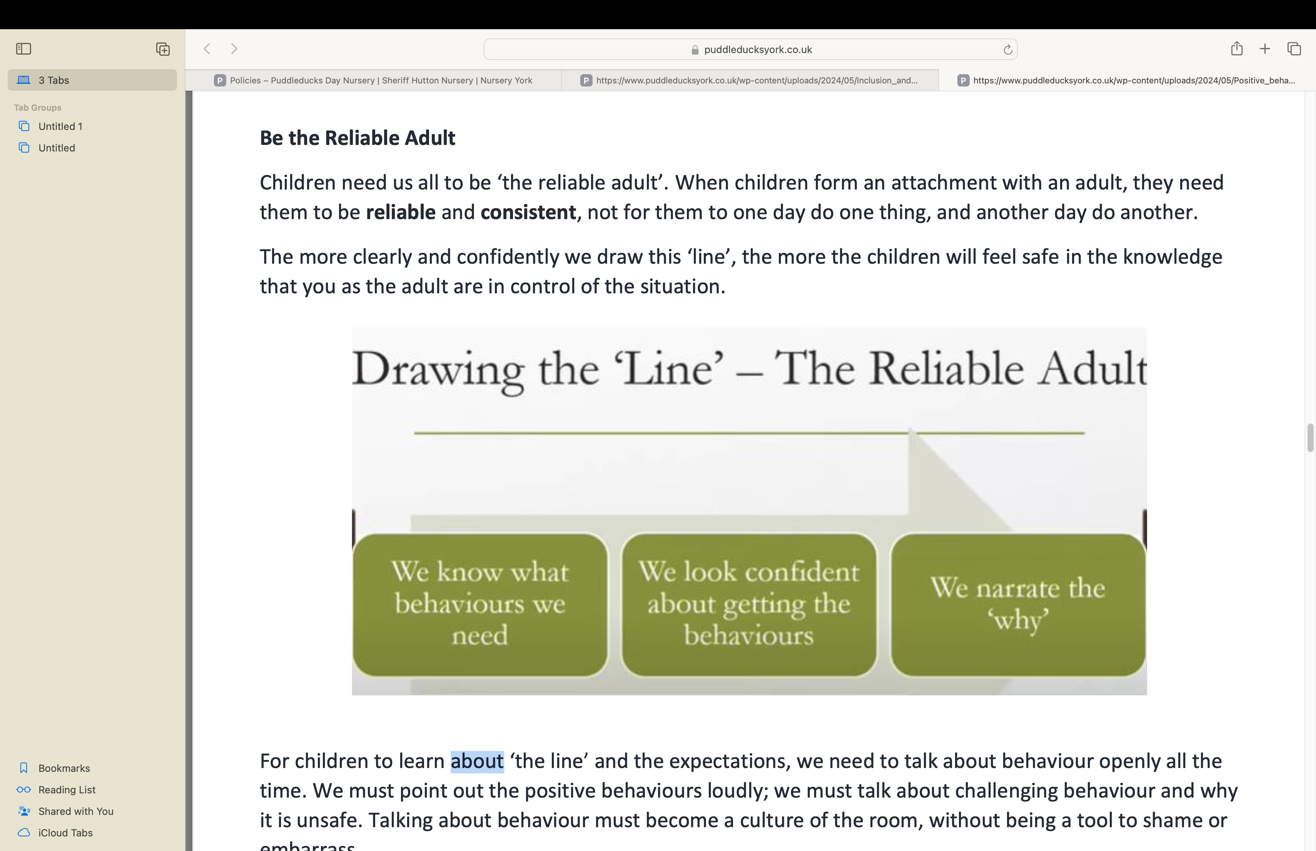

For children to learn about ‘the line’ and the expectations, we need to talk about behaviour openly all the time. We must point out the positive behaviours loudly; we must talk about challenging behaviour and why it is unsafe. Talking about behaviour must become a culture of the room, without being a tool to shame or embarrass.
Where adults appear confident, children have the perception of confidence, and they feel more secure.
Making eye contact, talking slowly, not doing lots of ‘umming and erring’, tone, clarity of voice, all impact on how our children perceive the adults and their ability to control a situation.
We need to ensure that the ‘why’ is always used when talking about behaviour, which will support children to develop the skill of empathy. As part of drawing the line, we must constantly go back to our expectations.
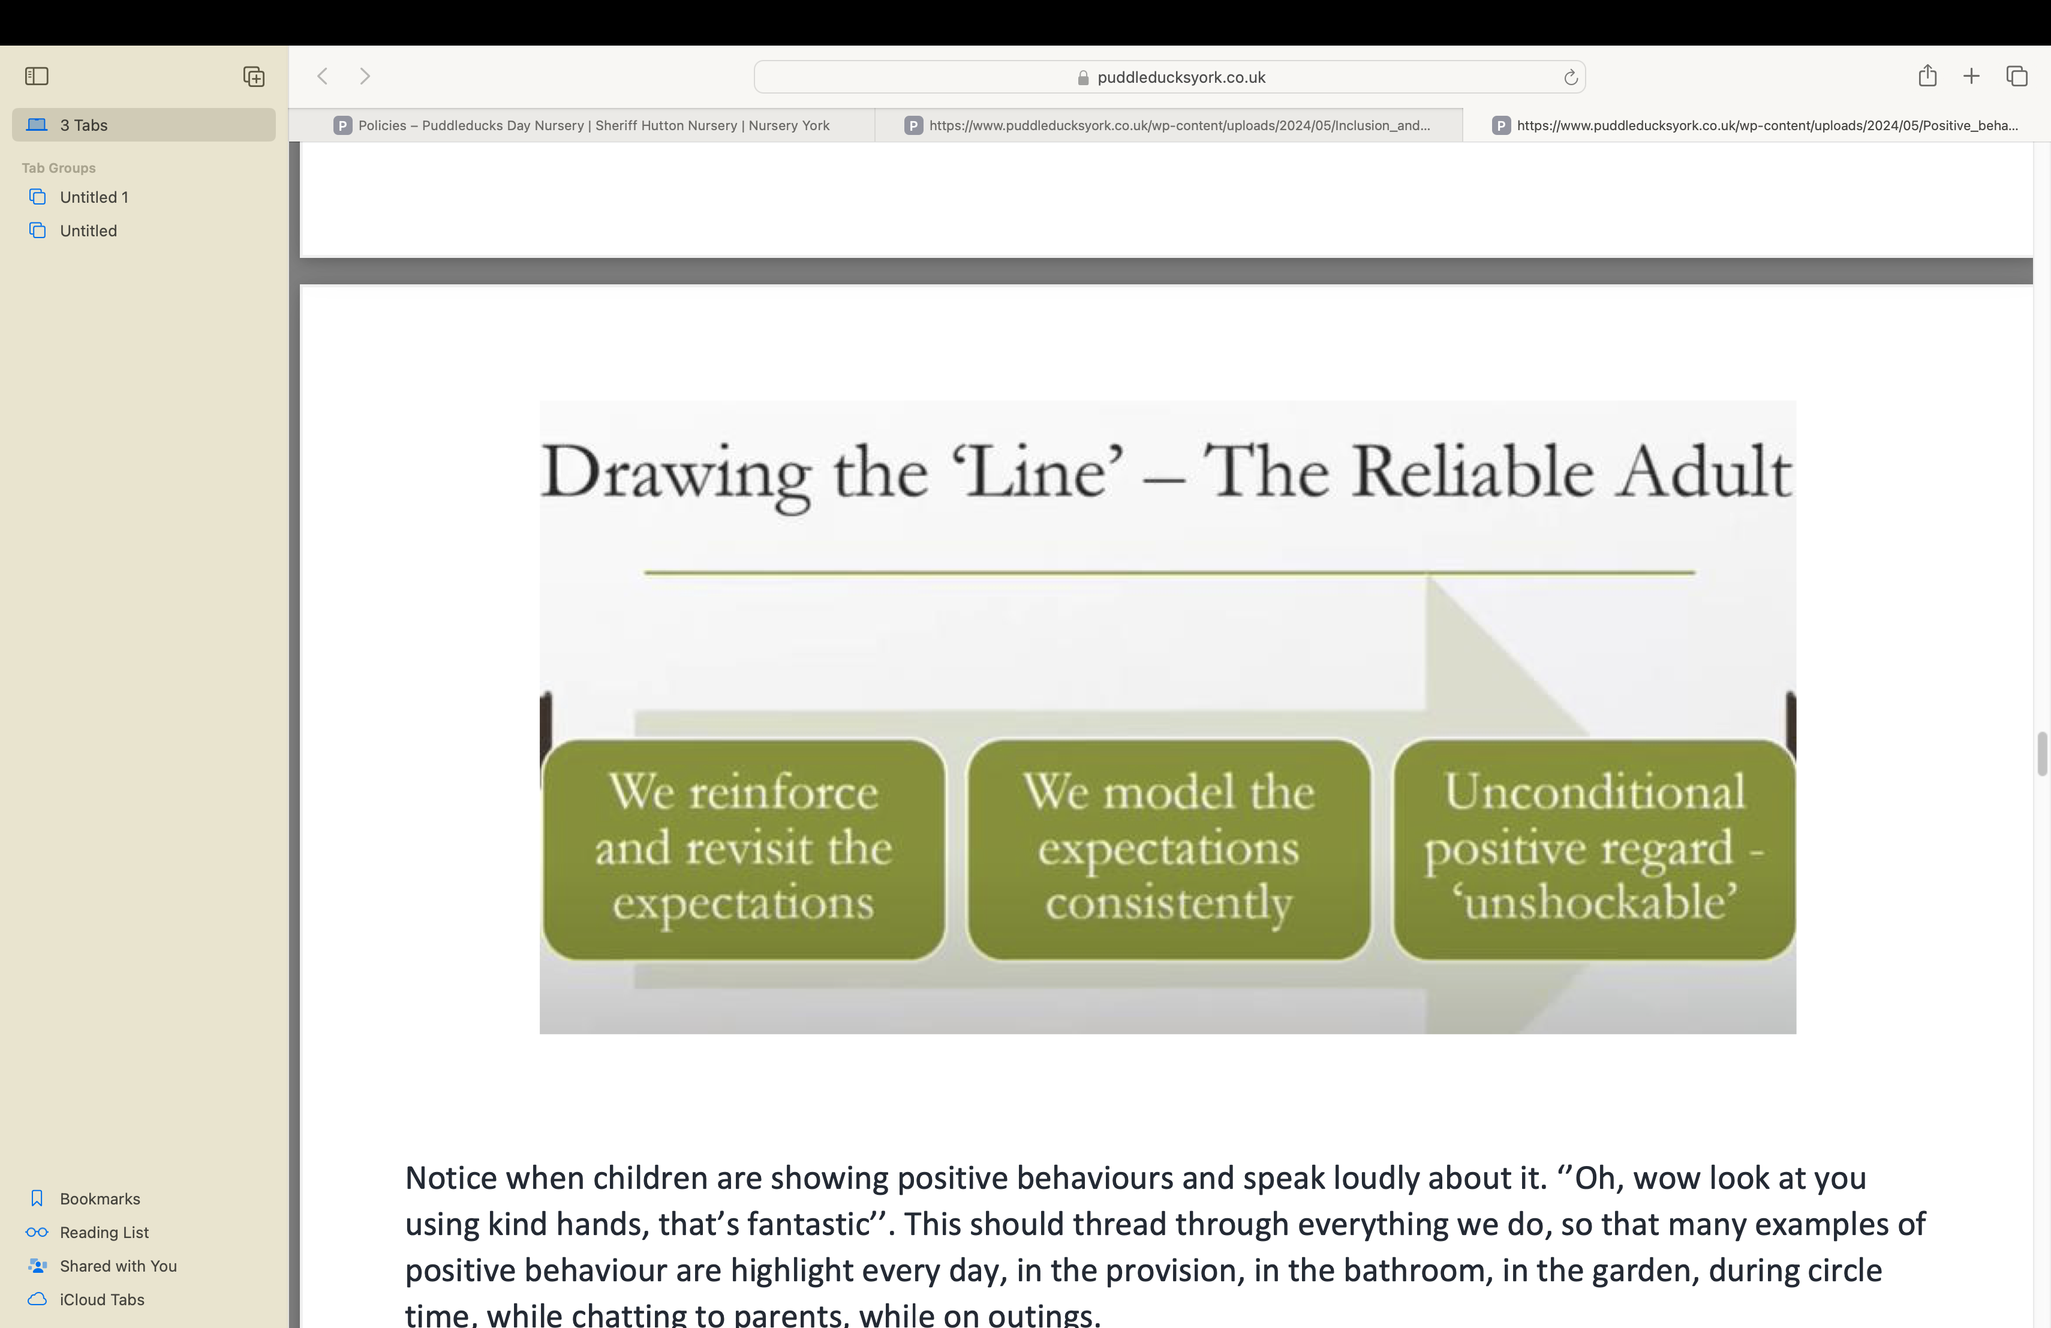

Notice when children are showing positive behaviours and speak loudly about it. ‘’Oh, wow look at you using kind hands, that’s fantastic’’. This should thread through everything we do, so that many examples of positive behaviour are highlight every day, in the provision, in the bathroom, in the garden, during circle time, while chatting to parents, while on outings.
It is essential that staff then model all the things they have said they expect from children. If we expect children to listen to us and each other, then we can’t talk over them. Modelling is crucial because children learn as much from the things we do, as from the things we say.
We will always keep the behaviour separate from the child, so no matter what a child has done, they must know that we still have professional love for them.

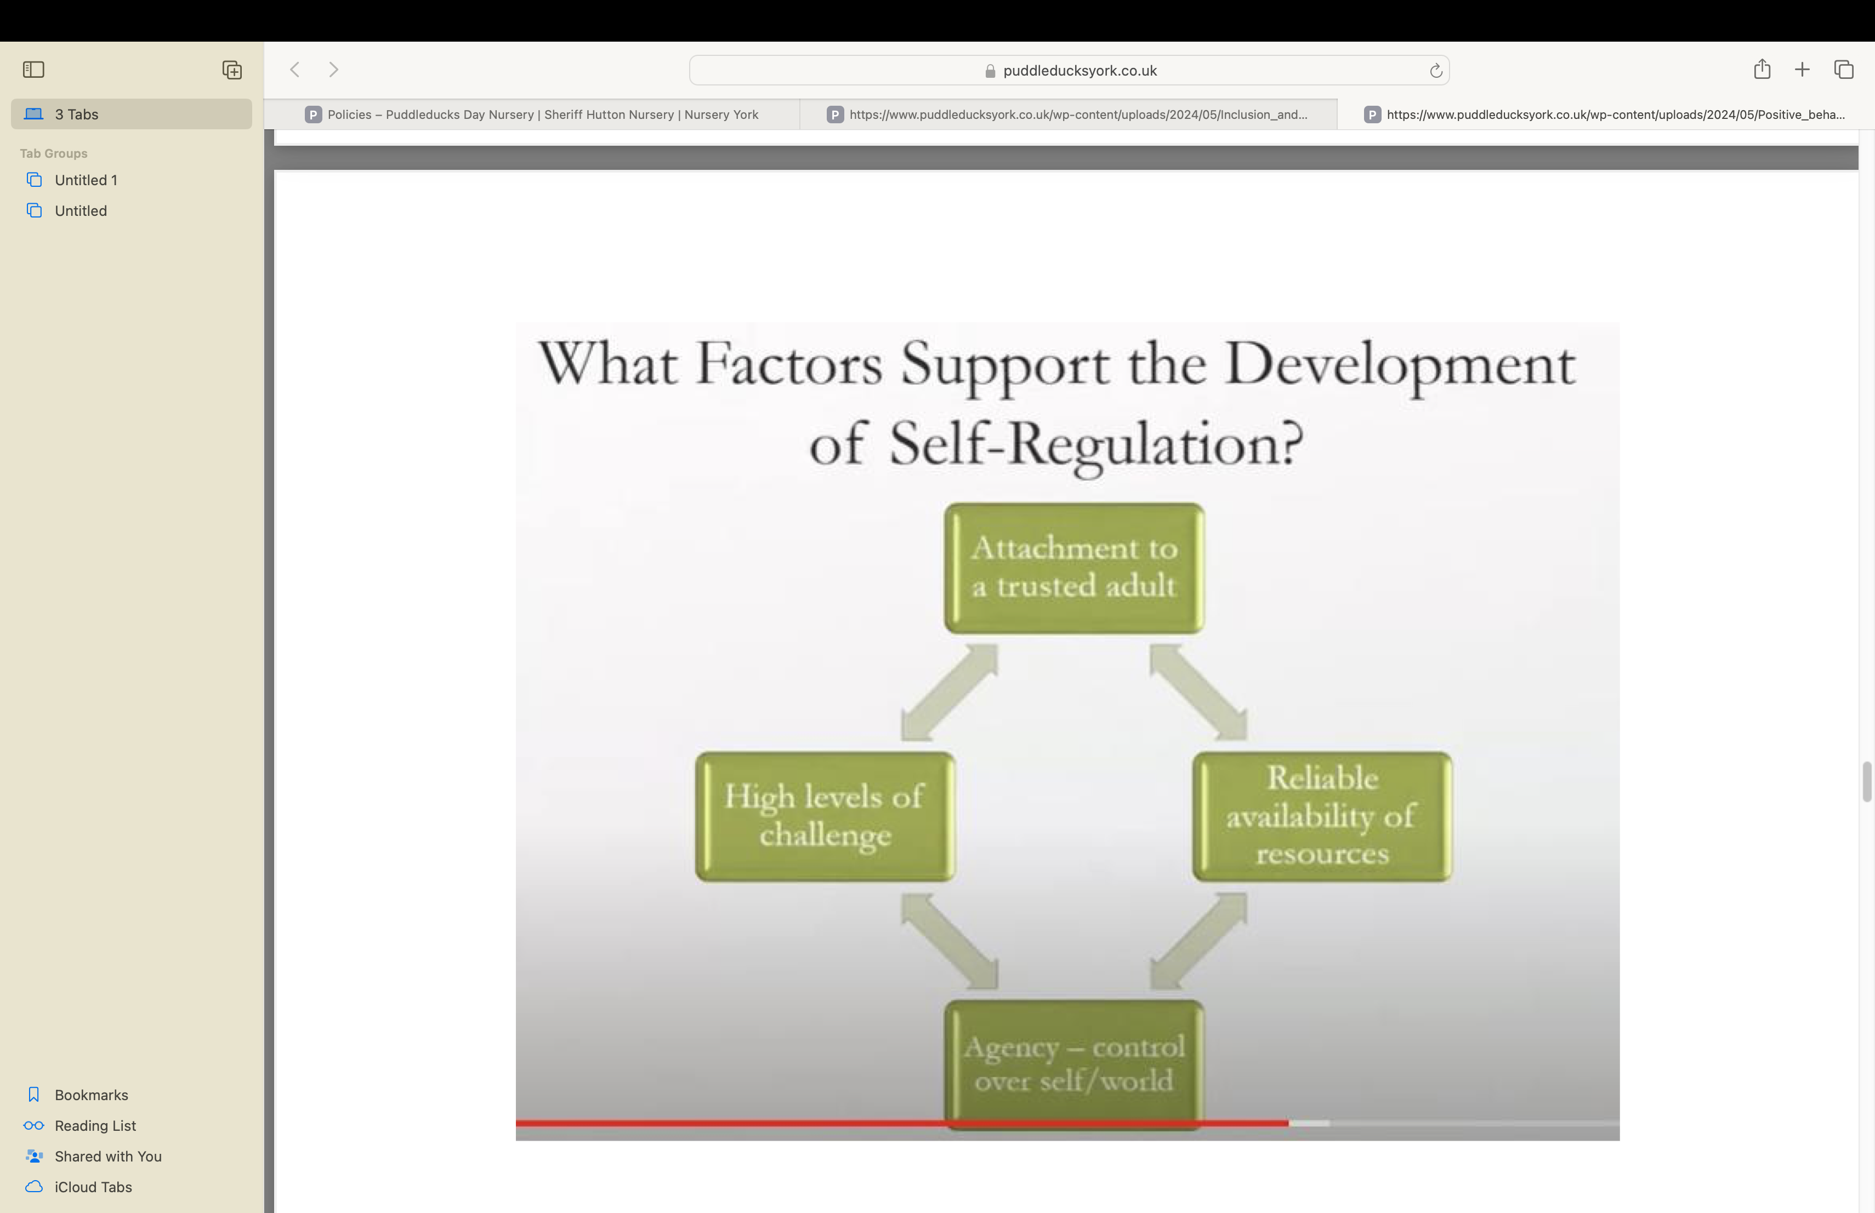

Parenting
It is crucial that children trust reliable adults, and that they trust the resources and routines of the setting.
Children need to feel that they are active agents in the world in which they live. They also need high levels of challenge.
We are mindful that children in our care have been exposed to a vast range of parenting styles and approaches. This can range from neglectful parenting to helicopter parenting (helicopter parenting is where parents overhelp the child all the time). Children who have been overhelped throughout their earliest years can struggle with self-regulation. Those children who have been overhelped are likely to struggle with failure because they have never been allowed the space to fail.
Transitioning from supported self-regulation to independent self-regulation.
We recognise our important role in helping children transition from requiring supported self-regulation to independent self-regulation. One essential tool for supporting this transition is routines used in the setting, which create a sense of security for the children.
During routines, we provide little opportunities for children to be ‘agents’. For example, providing children with opportunities to make choices is essential for developing self-regulation.
During interactions with children, staff must consider ‘am I interacting or am I interfering?’ ‘Am I overhelping?’. Where staff feel an urge to repair something for a child, they should first offer a little bit of verbal support. These moments of co-regulation, where the child is given time to achieve something for themselves, are vital in helping children develop the skill of self-regulation.
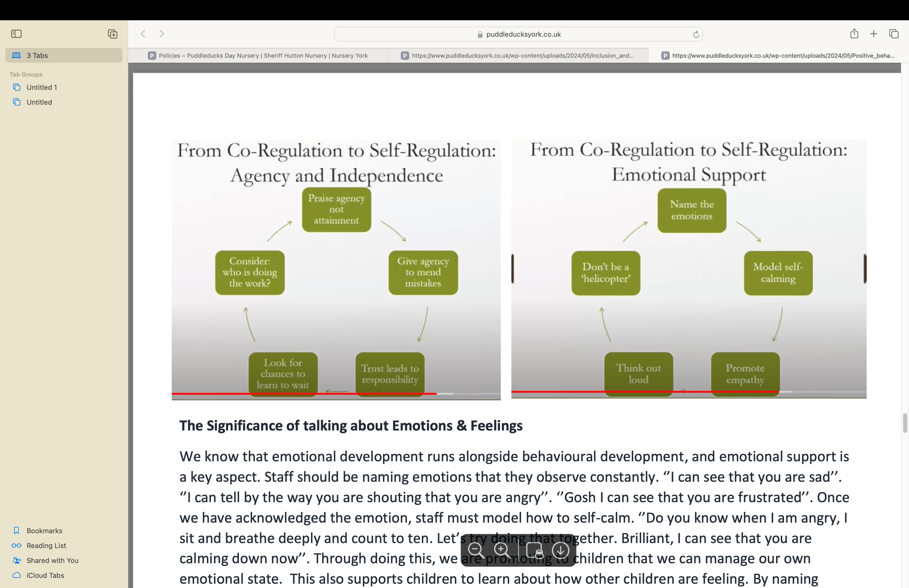

The Significance of talking about Emotions & Feelings
We know that emotional development runs alongside behavioural development, and emotional support is a key aspect. Staff should be naming emotions that they observe constantly. ‘’I can see that you are sad’’. ‘’I can tell by the way you are shouting that you are angry’’. ‘’Gosh I can see that you are frustrated’’. Once we have acknowledged the emotion, staff must model how to self-calm. ‘’Do you know when I am angry, I sit and breathe deeply and count to ten. Let’s try doing that together. Brilliant, I can see that you are calming down now’’. Through doing this, we are promoting to children that we can manage our own emotional state. This also supports children to learn about how other children are feeling. By naming emotions and talking about how it makes us feel when *this* happens, we are promoting empathy.
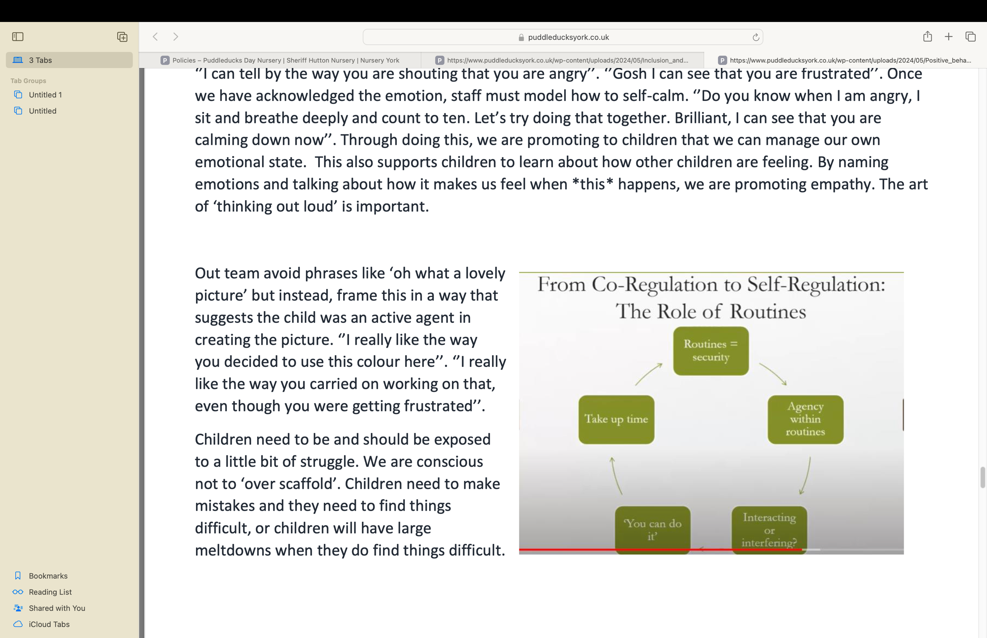
The art of ‘thinking out loud’ is important.
Out team avoid phrases like ‘oh what a lovely picture’ but instead, frame this in a way that suggests the child was an active agent in creating the picture. ‘’I really like the way you decided to use this colour here’’. ‘’I really like the way you carried on working on that, even though you were getting frustrated’’.
Children need to be and should be exposed to a little bit of struggle.
We are conscious not to ‘over scaffold’. Children need to make mistakes and they need to find things difficult, or children will have large meltdowns when they do find things difficult.

A Needs Based Analysis – When the Child’s Behaviour Puzzles You!
We must avoid leaping to assumptions before we have spent enough time observing. A stages process must be implemented.
1. What are the observed behaviours?
Do not label children or behaviours but be factual. Not ‘’I observed this child being unkind on the carpet’’.
‘’I observed the child sat on the carpet during story time and kicking out at the child beside them’.
2. What might that behaviour be telling us this child needs?
It could be that they need to be more active, or that they need a cushion to sit on. It could be that I need to improve my story-telling to make it more interactive. Start by observing, then pick it apart and only then start to think about possible effective strategies.
3. What strategies would help us meet the child’s needs?
As practitioners we sometimes want to find a strategy that will solve everything but it is rare that strategy exists so this should be avoided! Often it is not about strategies but reflecting and looking closely at the provision.
4. What can we change about our provision to make it more inclusive and to better meet this child’s needs?
Perhaps this child is not having their needs met through the teams planning. Maybe this child would benefit from getting out on a daily walk to burn some energy off. Sometimes it is not only the provision need, but also a staff training need. Do staff in the team need some training/coaching in an aspect of their practice?
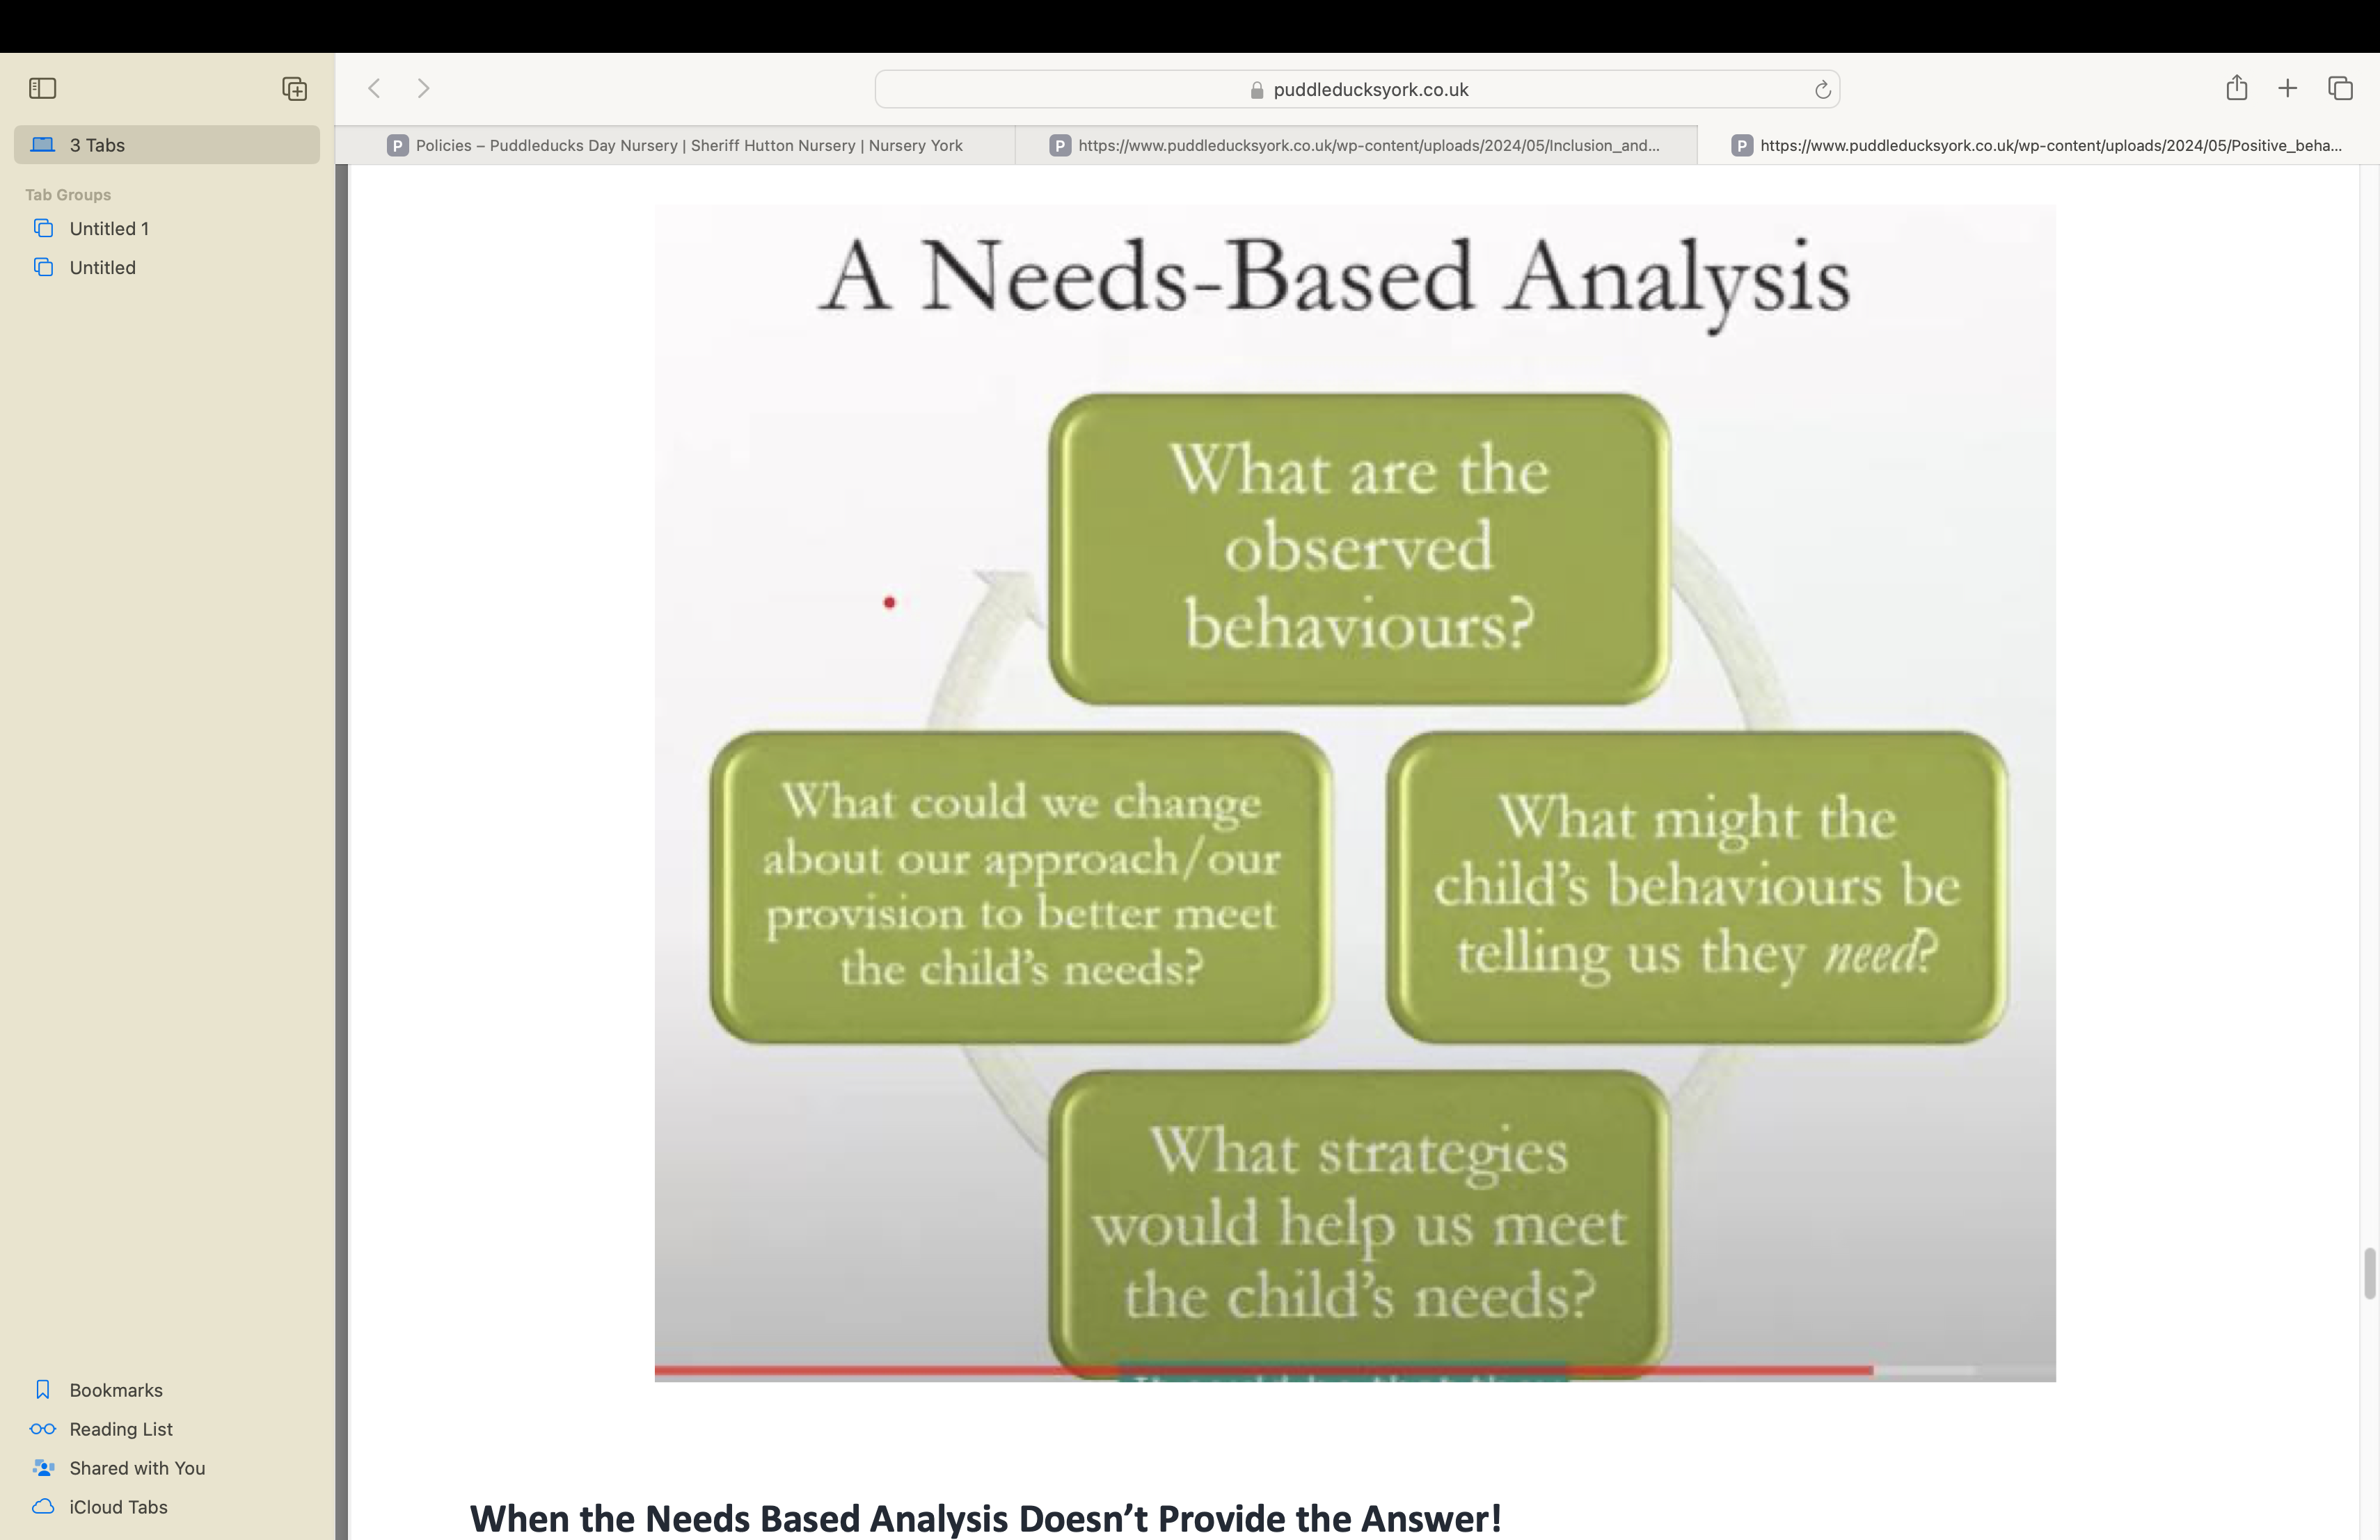

When the Needs Based Analysis Doesn’t Provide the Answer!
It is often more common that the root cause of challenging behaviour is not obvious. It might sometimes be the case that a bereavement, or the arrival of a new baby, or a house move is an obvious factor impacting children’s behaviour but usually, there is not an obvious external factor and this can be frustrating.
Often multiple factors feed in to create a particular behaviour, some of which will remain unidentified.
Some of these factors might be historical; some current; and there will be factors about that child’s personality also playing a part.
When we don’t understand the cause of the behaviour, it is important to just get in touch with the feeling.
Put the reason/cause aside and focus on the feeling. Sometimes reflecting on our own feelings in that moment is very helpful. If we are feeling overwhelmed or frustrated due to an environmental factor, chances are the child is too.
Children are unlikely to tell us about factors in their lives that might be affecting them but conversations with parents and carers might bring factors to light that can help us understand.
It is rare that we will ever get a definitive explanation for a child’s behaviour.
The answer can normally be found here…
‘’What can I do to change the curriculum to better meet this child’s need’’.
We should avoid using the word ‘NO’. If we find ourselves saying ‘no’ regularly, then we are being reactive, not proactive. Children will only respond negatively to the word ‘no’. Feeling the urge to say no often would suggest that our expectations ‘the line’ has not been made clear to our children.
Working in Partnership with parents to support children’s behaviour
We will always share our earliest concerns about a child’s behaviour with parents. In the first instance this will be done through discussions with parents and key person.
We will work together with parents to try and develop a shared understanding of what might be going on and causing some of the challenging behaviours. In collaboration with parents, a shared approach to supporting the behaviour will be agreed. Strategies may be recorded in an individual learning and provision plan with the support of the nursery SENCO.
Expressions of anger and upset do vary according to culture. Talking openly with parents will help us to understand more about how individual children behave when upset.
Joining together to create a shared understanding and approach with parents will enable a shared and consistent approach, which will be helpful for the child.
Adults have attachment needs to…
As adults, we also need the time and space to express feelings and be listened to. Working alongside children who are displaying challenging behaviour can be stressful and exhausting. Staff need comfort and reassurance from fellow team members who they trust. It is essential to have the time and space to reflect on difficult experiences with children, with supportive and reflective peers.
At Little Adventurers we recognise and prioritise staff well-being. The setting Special Educational Needs Co- Ordinator (SENCO) is available to listen and offer support and advice to staff. The setting manager is also available to staff for support and advice.
External Support
We will seek advice from external agencies in some circumstances:-
• Where we are worrying a child’s difficulties are impacting their development or their behaviour becomes so disruptive it is impacting other children’s development.
• Where we struggle to identify strategies to help calm and contain them.
• Where we feel we cannot keep them, other children and/or staff safe.
• We will trust our instincts. It is better to seek help early than to wait for things to deteriorate.
We will always share our concerns with parents, and where appropriate colleagues before seeking external help.

This Policy was adopted on: | Signed on behalf of Nursery: | Date to be reviewed:
01/10/2024 | A.Wood-Dobby | 01/10/2025

